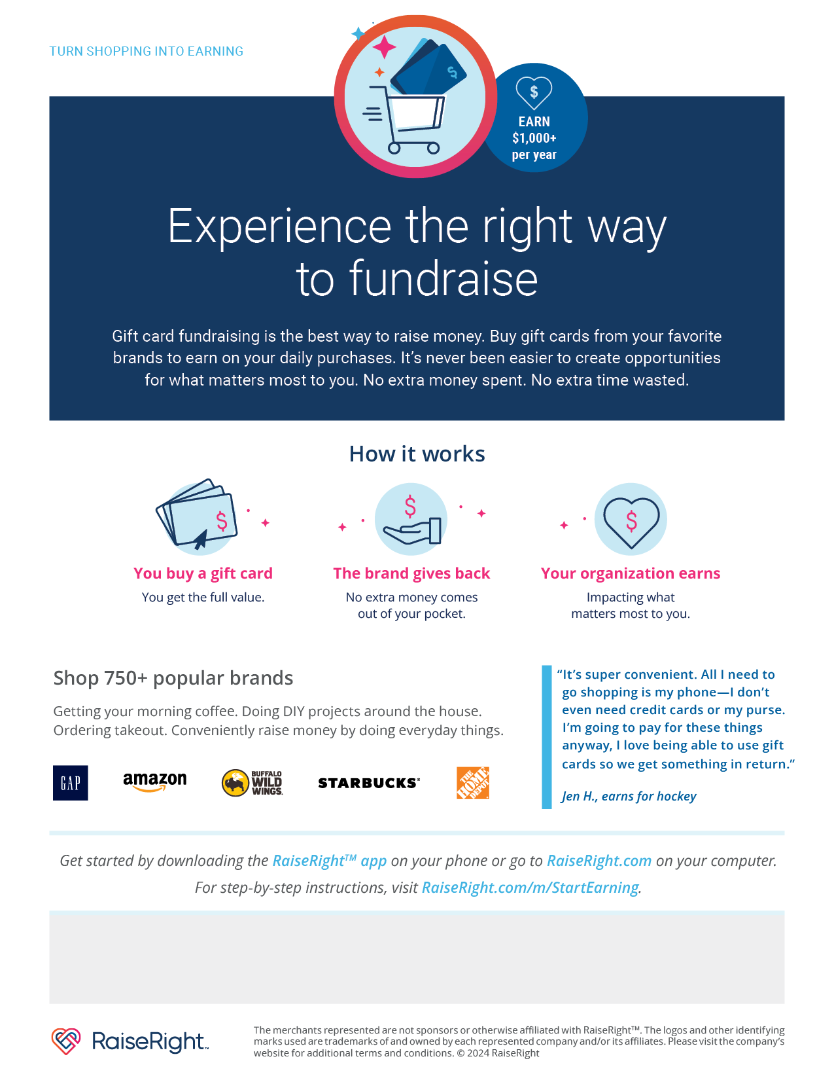

Please use unique code **35CRJ98QVD8Q** for Crittenden Middle School PTA when ordering.EGift cards, Physical gift cards, and reloadable gifts cards are available for purchase. For any questions or assistance, please contact Sigi Del Rio at [Sigifredo_del_rio@yahoo.com](mailto:Sigifredo_del_rio@yahoo.com).